eStroke Referral
Training Guide

Version 1.0
May 12, 2022

Document History
Date | Author | Version | Change(s)
May 12, 2022 | Tom McNeil | V1.0 | Initial Release

Table of Contents
eStroke Referral Training Guide 5
Introduction 5
eStroke Referral Standards 5
Referrals to Inpatient Providers 5
Referrals to Outpatent Providers 5
Sending a Referral 6
Overview 6
Key eStroke Tab Details 8
Client Details 8
Demographics 8
Supplementary Information 9
Acute Medical Assessment 10
Social Information 10
Care Requirements 10
AlphaFIM® 11
Orpington Prognostic Score 12
COPM 13
Functional Assessment 14
Communication and Swallowing 14
eStroke Summary 15
Calculations 15
Client Choice Overview 17
Uploaded Files 19
Completing the Client Choice Tab 19
Send and Manage referrals 20
Canceling and Deactivating Referrals 20
Cancel a Referral 20
Deactivating a Referral 21
Receiving Referrals 22
Viewing Referrals 22
Creating a Vacancy 26
eStroke Vacancy Dashboard 31
Overview 31
Accessing the Dashboard 31
Admitted Patient COPM and FIM 31

eStroke Referral Training Guide
Introduction
This training document introduces features associated with the new eStroke care pathway. Clinicians will now be able to send electronic referrals to eStroke Units using RM&R. This pathway introduces some new functionality as outlined in this user guide.
Receiving organizations will be able to post their bed availability using the Vacancy module. This allows sending organizations to see where bed availability is within the region at any given time.
eStroke Referral Standards
The eStroke Program has specific guidelines for sending and receiving referrals including limits on the number of units to send to and the time to respond to a referral. It is important to provide clear and objective descriptions of the medical, functional, activity level and participation in therapy. Teams should work together to ensure consistency and accuracy in the information across all aspects of the referral.
Referrals to Inpatient Providers
- Typically refer to no more than 2 rehab sites closest to the patient’s home postal code or anticipated home discharge destination. If the rehab organizations are unable to admit within 2 days, apply to 2 additional sites.
- Response from rehab within 2 hours of referrals sent on business days (note: next business day if after 3:00pm).
Referrals to Outpatient Providers
- Refer to 1 outpatient site closest to the patient’s home postal code or anticipated home discharge destination.
- Response from rehab within 1 business day
- For patients with AlphaFIM® Instrument score >80, referrals should be automatically accepted.

This training guide is broken down in 4 sections; Sending referrals, Receiving, Creating Vacancies/Admitting patients and Admitted Patient Canadian Occupational Performance Measure (COPM©) and FIM® Instrument (FIM®) . This guide will focus on key steps in completing, sending and receiving referals for the eStroke pathway. For more detailed information on specific steps, you can refer to quick guides available on our public website:
Quick Guides – Resource Matching & Referral (resourcematchingandreferral.com)

Sending a Referral
Overview
When a user initiates a new referral, they will see something similar to the image below.
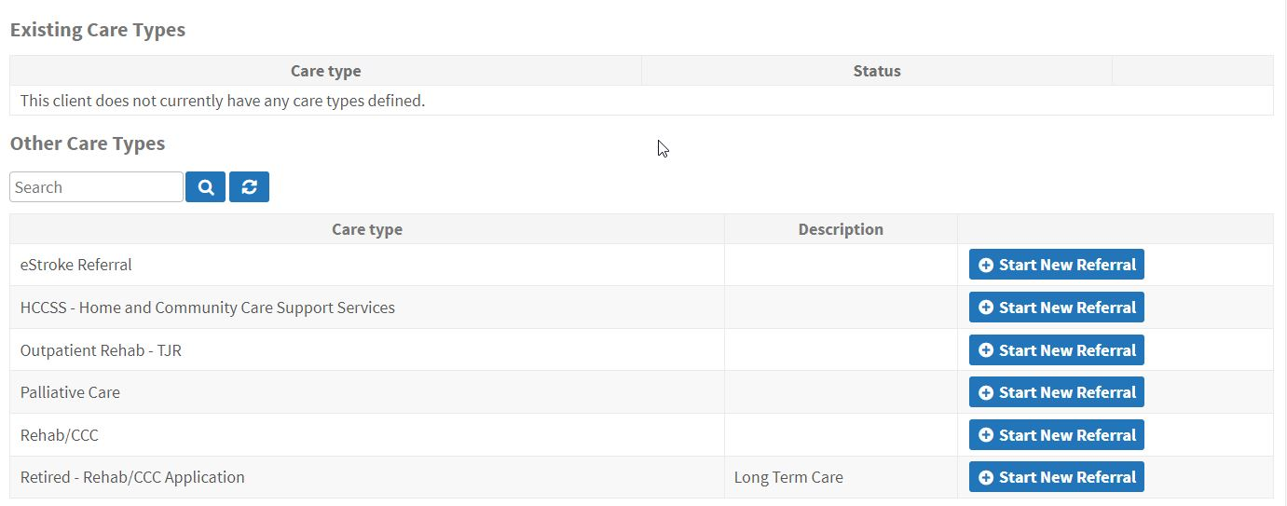
Here they will be able to select the new eStroke Referral care type. Selecting Start New Referral will take the user to the following page.

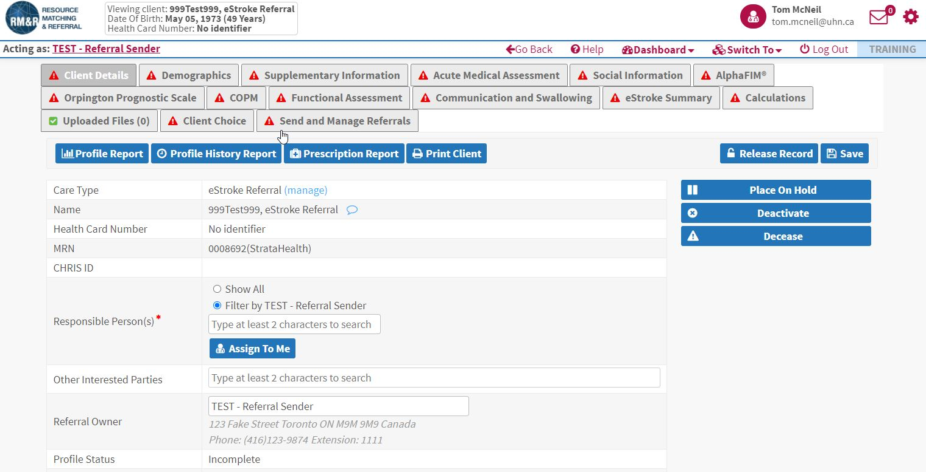
The eStroke pathway is broken down into 16 separate ‘tabs’ or pages. As a user completes any of the mandatory information on each tab, the icon will change from to 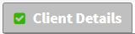 with the green checkmark indicating you can proceed with the referral.
The following table provides a brief description of the information found on each of the tabs in the eStroke Referral.

Page | Description
Client Details | High level patient information. Users will assign the referral to themselves on this page.
Demographics | Patient details including Health Card Number, MRN, contact information and current location.
Supplementary Information | Additional demographic information not captured in the previous page and high level refferal information.
Acute Medical Assessment | Details on the current stroke episode.
Social Information | Information relating to the patient’s finances and living situation.
Care Requirements | Details around the care required for the patient in the Rehab setting. *Note: this tab will not appear for Outpatient Referrals.
AlphaFIM® Instrument (AlphaFIM®) | Links to the AlphaFIM® scoring tool. Up to 4 separate AlphaFIM® assessments can be documented on this page.
Orpington Prognostic Scale | All options associated with the Orpington Prognostic Scale scoring tool.
COPM© | Identification and documentation of Occupational Performance Problems.
Functional Assessment | Details of current state of patient and their ability to perform specific tasks.
Communication and Swallowing | Completed by Speech Language Pathologists. This page documents any issues a patient experiences with speech or swallowing after the current stroke event.
eStroke Summary | A high level summary of key items from the previous pages. This is for Receiving Organizations to be able to view the patient at a glance.
Calculations | Performs the various calculations of the scoring tools and populates the values in the blank fields.
Uploaded Files | Any additional documents that are shared from the sending to the receiving organization.
Client Choice | Select the Rehab Facilities/Units that the referral is going to.
Send and Manage Referrals | Send and monitor the status of a referral.

Key eStroke Tab Details
The following section provides an overview of key data elements specific tabs that are required for a referral to be marked as complete.
Client Details
On this tab, users are required to enter the Responsible Person for the referral. This is normally the individual initiating and completing the referral. Clicking on the Assign to Me button will populate the field with the user’s name and complete the tab.

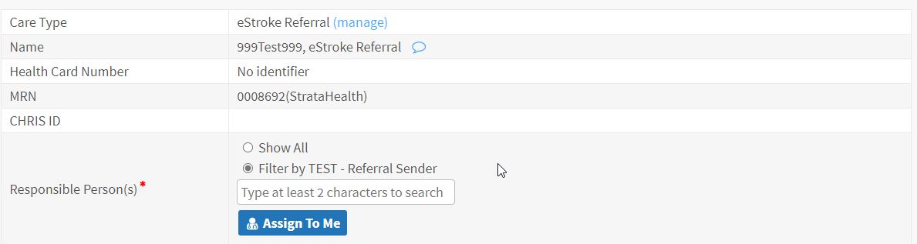
Demographics
This tab contains contact information for the patient including address and alternate contact information. If accessing the patient through your Electronic Patient System, some of these fields will be prepopulated. Key pieces of information on this tab are Date of Birth, Client Address, Alternate Contact information and Current Location.
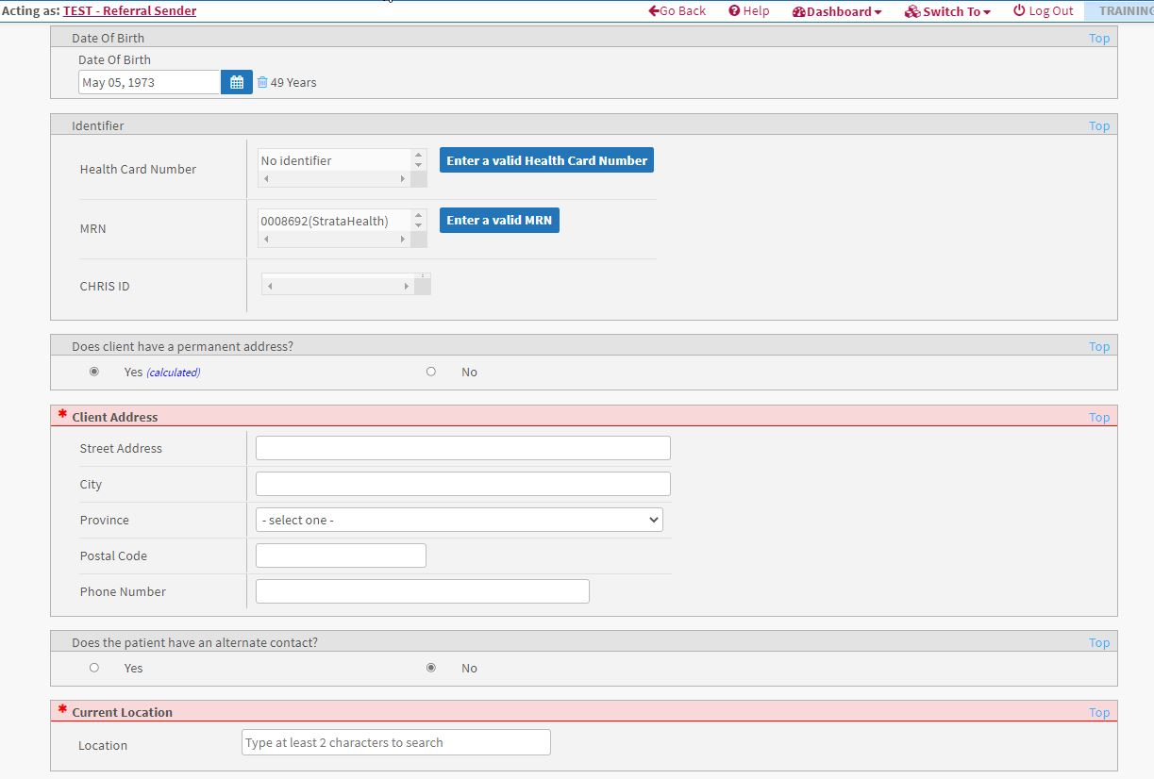

Supplementary Information
This tab contains some general referral information such as the patient’s gender, Rehab setting type and when the patient will be rehab ready.
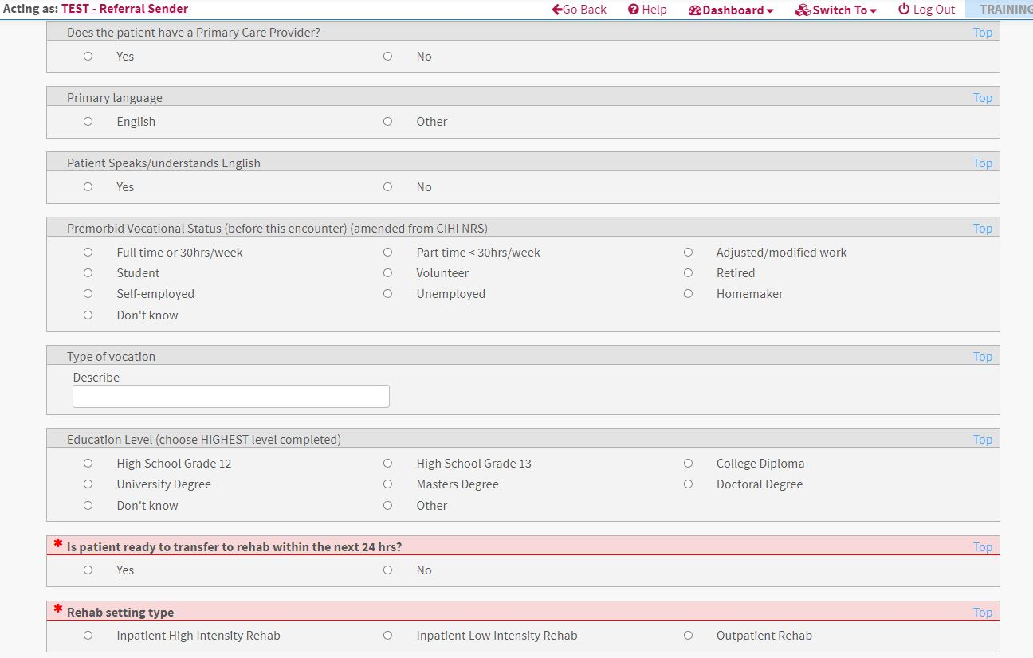
Fields that are in red are mandatory and are required to complete the tab. The Rehab setting type question will remove the Care Requirements tab based on the option selected. Outpatient Rehab will remove the Care Requirements for the patient. This is displayed below:
When Inpatient rehab selected:
When Outpatient rehab selected:
This reduces the amount of information that a user needs to complete when sending an Outpatient referral.

Acute Medical Assessment
The stroke related details contained on this page provide the receiver information on the diagnosis and treatment of the patient. The Charleson Comorbidities Index are located on this page. This category is a key piece of data used later in the referral for calculations and is a mandatory field.
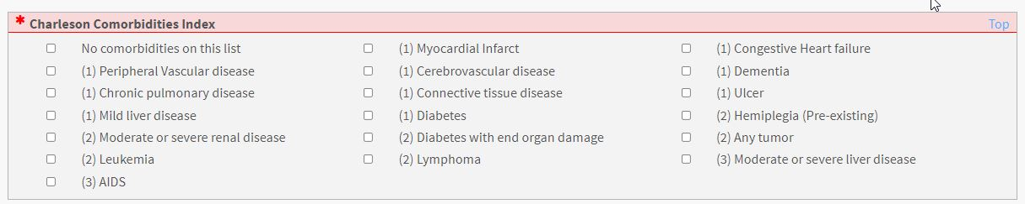
If a patient does not have any of the listed comorbidities, selecting the No comorbidities on this list will satisfy the mandatory aspect of the category.
Social Information
The patient’s finances and home living situation are located on this tab. There is only one mandatory field on this page.
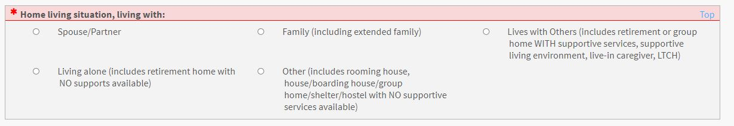
Care Requirements
As shown above, depending on the Rehab setting type, this tab may or may not appear. For Inpatient rehab, users will need to complete all mandatory fields such as Beahviour, Safety and Support Required. 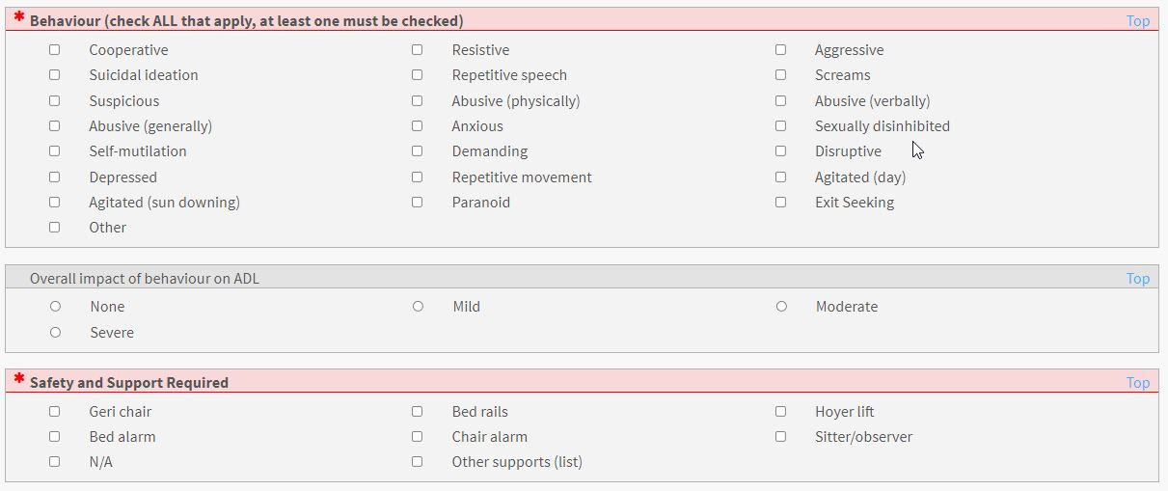

AlphaFIM®
On this tab users have the option to complete up to 4 AlphaFIM® assessments. Each option they select will bring up the necessary additional fields required to complete the tool.
The order of the assessments will be newest to oldest wich each new assessment appearing at the top.
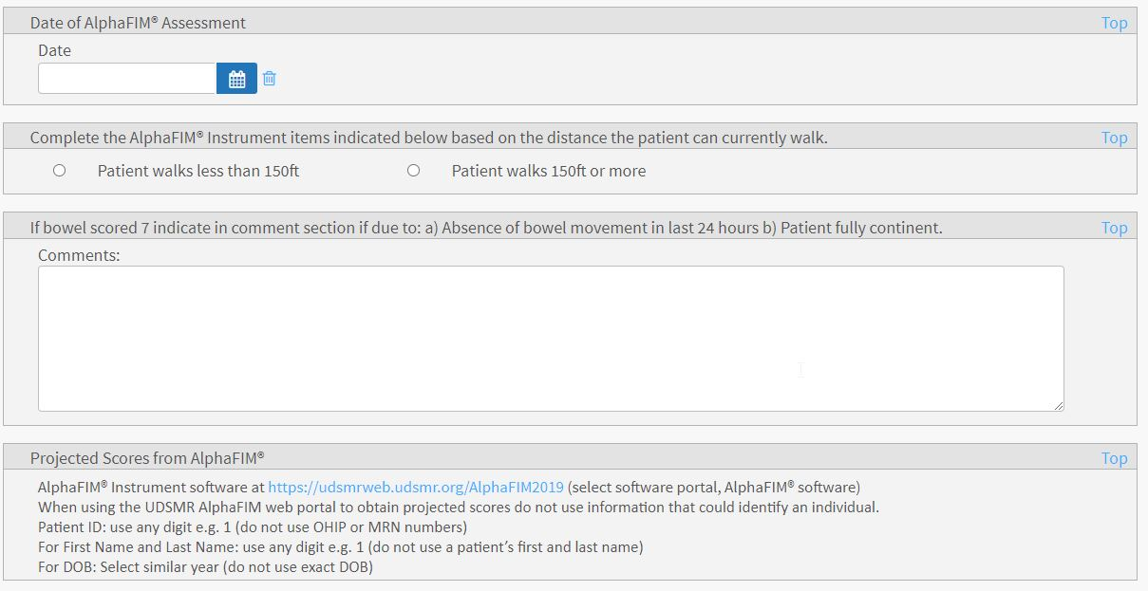
The link to the UDSMR tool is available within the form. Clicking on the link (blue text) will launch a new browser window where users will log in to the AlphaFIM® tool and enter the relevant information. They will then copy the resulting scores into RM&R.
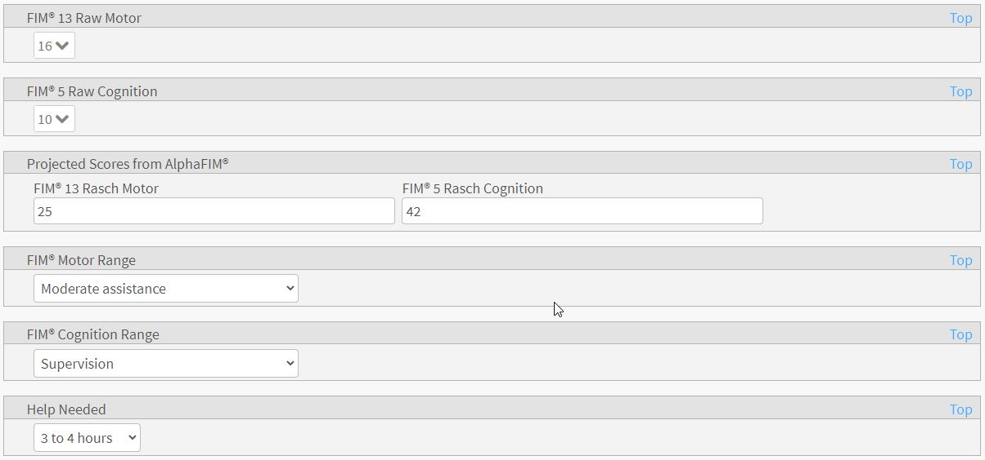
Orpington Prognostic Score
On the Orpington Prognositic Score tab, there are 4 mandatory fields. These fields are part of the calculations later in the referral and should be completed with every referral possible. There is a link to a Tip Sheet located at the top of the form if users need some additional details.
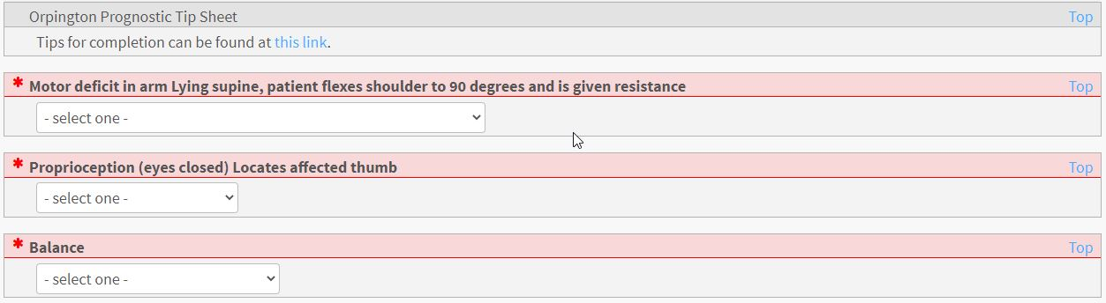
If unable to complete the Orpington Prognostic tool for any reason, users are to complete the below field with details on the status of the patient.
This field does not satisfy the mandatory requirements for the form and users will need to put information in the previous fields, but can provide context for those scores in this text box.
There are also the Stroke Modifiers associated with this tab. These will have an impact on the scoring for the Orpington Prognostic tool and are factored in the calculations later on in the referral.
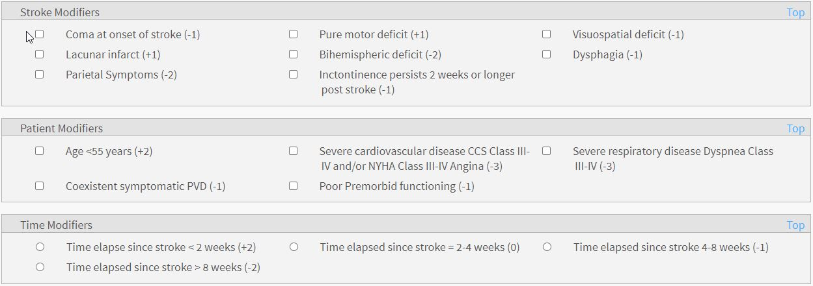

COPM©
This tab has a trigger as the first question.
If the user did not complete the COPM, they will be asked to provide a reason why it was not done.
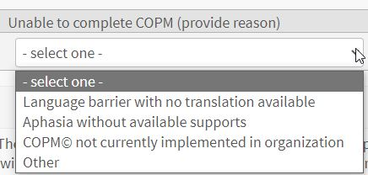
If the user selects yes, they will be able to proceed and select up to 10 Occupational Performance Problems and indicate the Importance of that problem to the patient.
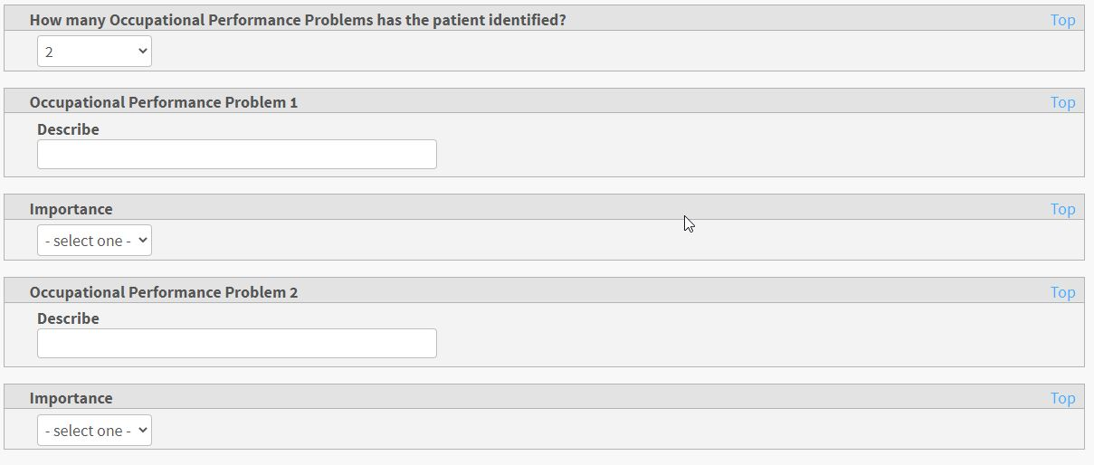
If a patient wants to add more than 10, there is an option to document an additional 10 Occupational Performance Problems.
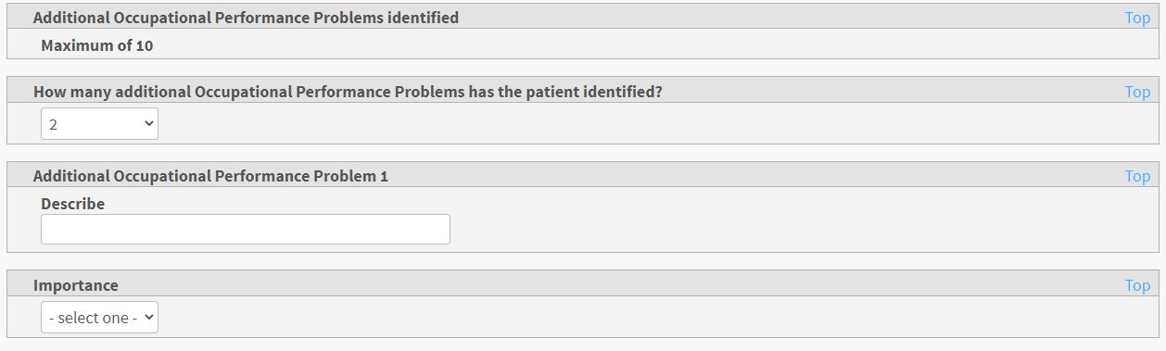
Functional Assessment
This tab has multiple mandatory fields around the patient’s functional status. Each of these will need to be completed in order to send the referral.
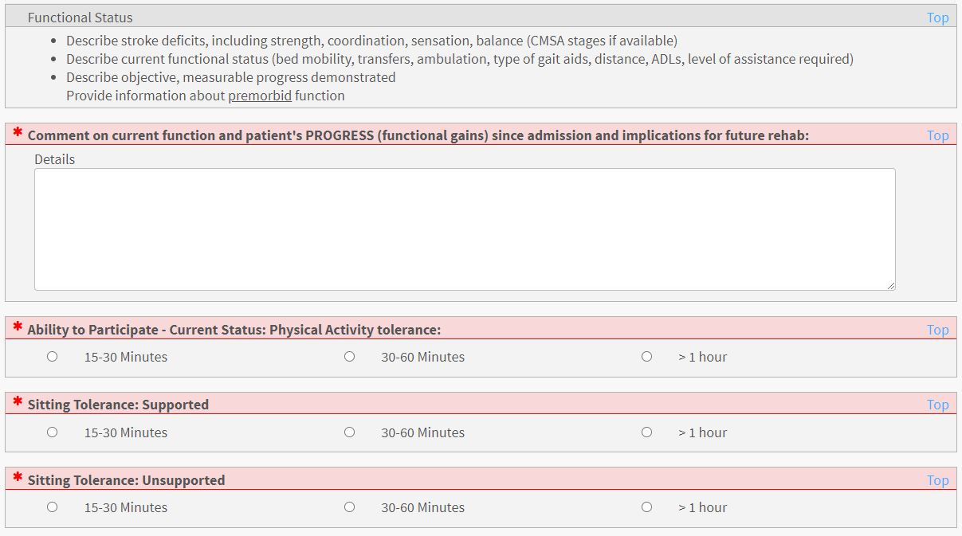
Communication and Swallowing
This tab also has a trigger question at the start. Answering No will satisfy the mandatory field and no additional information will need to be entered.
Answering Yes will bring up additional fields to be completed.
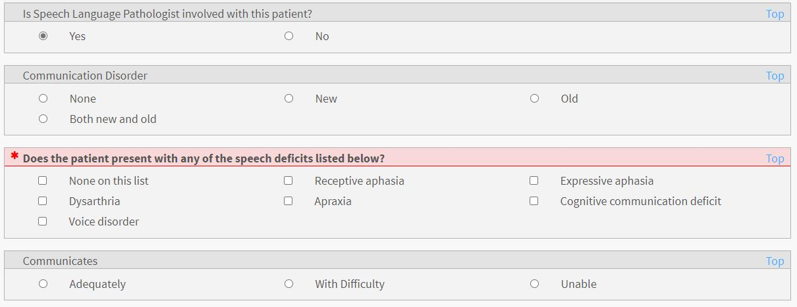

eStroke Summary
This tab contains information from all of the other tabs and compiles it into a summary for the receiving organization to review quickly. Users are not able to edit this tab directly. If there are fields that are still red, please review and complete them on the appropriate tab.
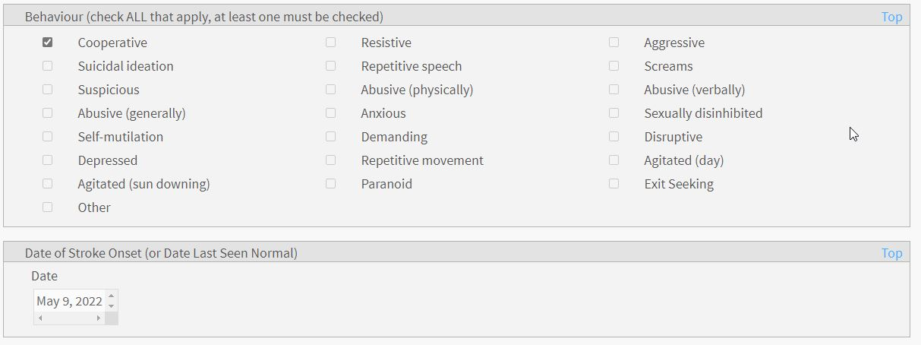
Calculations
This tab contains new functionality that will calculate all of the various scoring tools that were completed on the previous tabs. All of the information that was entered and is an input into a calculation will be prepopulated on this screen.
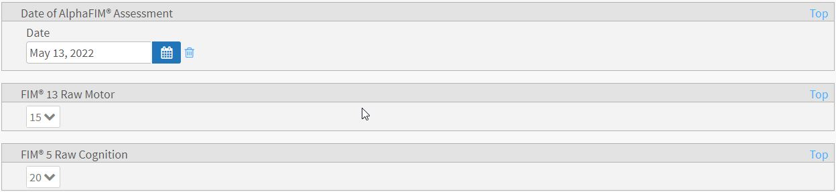
If multiple AlphaFIM® scores have been documented, they will each appear on this tab for the user to complete the calculations
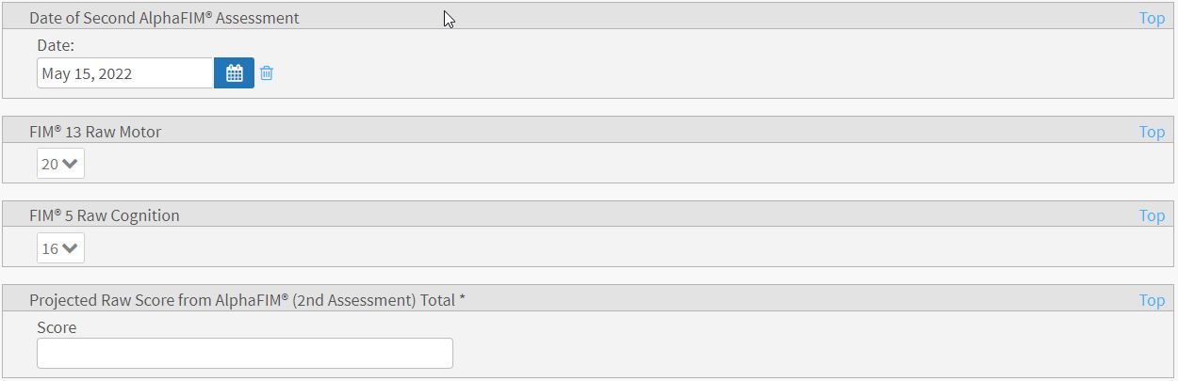

Fields that are red (mandatory) are data elements that will be completed by the calculation.
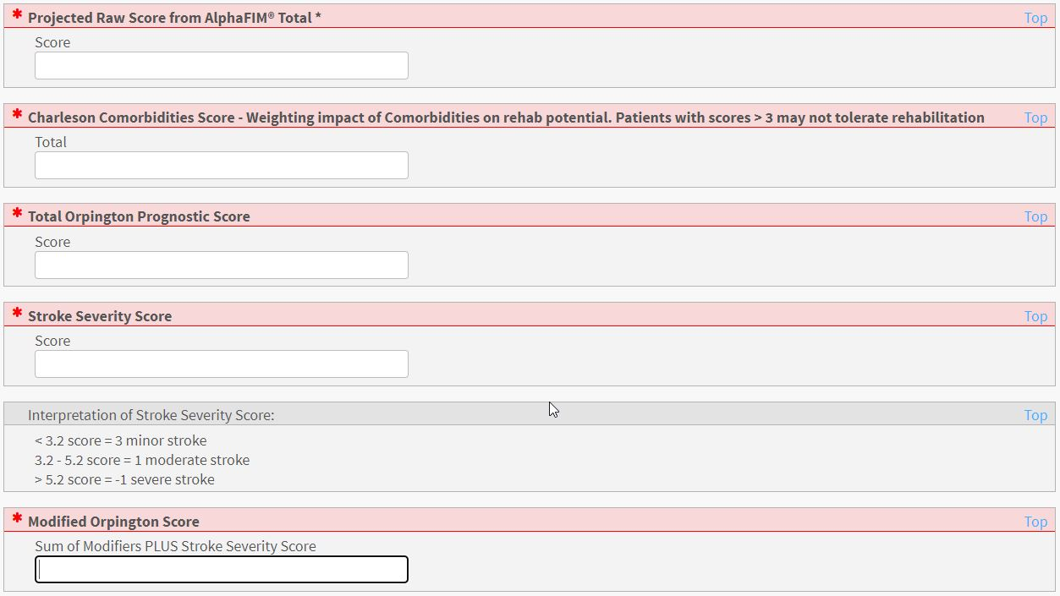
To Calculate all scores, users can navigate to the top of the screen and look for the Calculate Scores button:
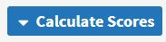
This will bring up additional options for the user to select:

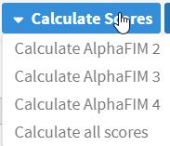 | Calculate AlphaFIM2® – calculates the scores entered for the 2nd AlphaFIM completed and populates the respective fields.
 | Calculate AlphaFIM3® – calculates the scores entered for the 3rd AlphaFIM completed and populates the respective fields.
 | Calculate AlphaFIM4® – calculates the scores entered for the 4th AlphaFIM completed and populates the respective fields.
 | Calculate all scores – calculates all of the different tools and populates their respective fields.

In the even that not all of the inputs are entered correctly, users will get an error message at the top of their screen indicating the calculation failed.
If this happens, go back and check that all scoring options are completed and click on the Save button on each page.
If all fields are completed correctly, users will get scores back into the fields that were previously mandatory as seen below.
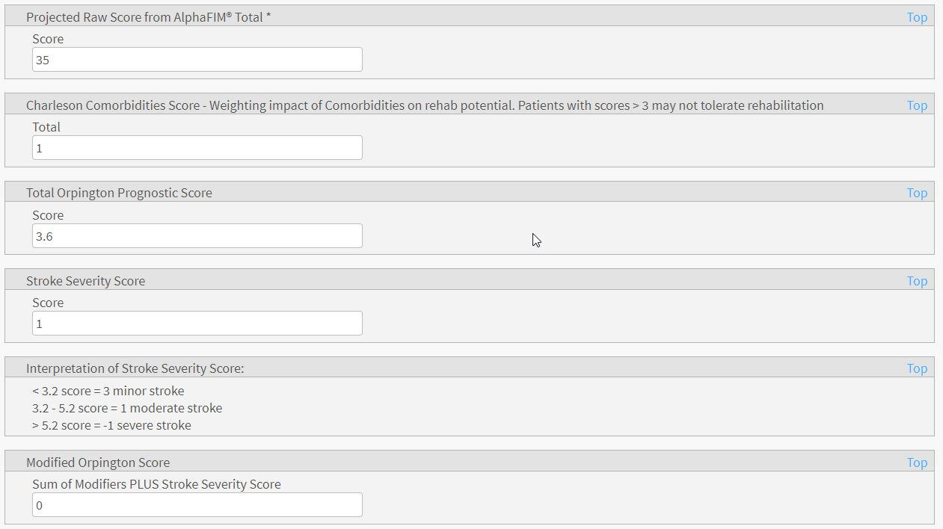
*Note – Additional AlphaFIM® scores are not calculated in the All in One option. Users are required to do each calculation separately for each subsequent scoring.
Client Choice Overview
This is where users will select the Rehab facilities that they are sending the referral to. A reminder that the eStroke guidelines are to send to 2 providers for Inpatient services and for to 1 provider Outpatient services.
On this tab, users will need to complete several pieces of information before they can send the referral. All service providers; High Intensity Rehab, Low Intensity Rehab and Outpatient Rehab are included on this screen.
An overview of the Client Choice tab is below.
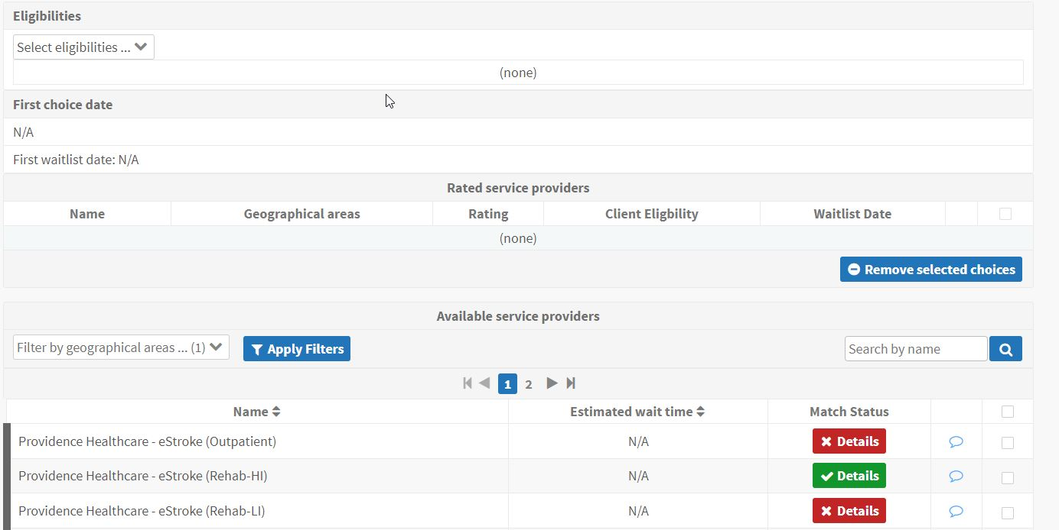
1
2

Depending on the Rehab destination that the user selected on the Supplementary Information tab, the patient will match to the appropriate level of care.
1
Patient matches referral destination | Patient does not match referral destination
Clicking on the Details button will provide further information on why a patient may not match to the destination provider.

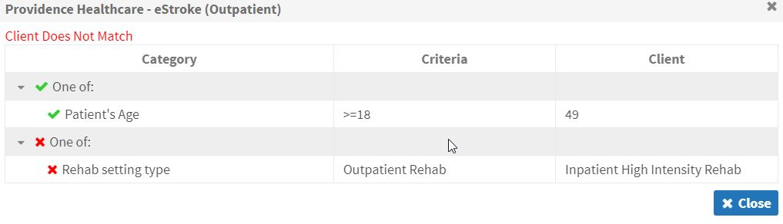
In the upper left corner, there is an option for Eligibilities. This enables receiving service providers to match a patient to a bed for specific criteria. For the purposes of eStroke, there are 3 Eligibilities; None, Hemodialysis and Peritoneal Dialysis. If a patient requires neither of the other options, users can select None. This will be made more clear when looking at the Vacancy Matching section of this guide.
2
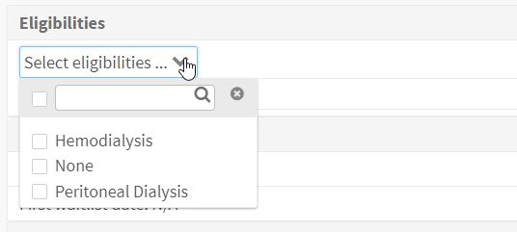
Uploaded Files
On this tab, you can upload any additional documents that may be necessary for the referral. To review this functionality, please refer to our Quick Guide: How do I attach a referral?
Completing the Client Choice Tab
Once you have determined the appropriate provider to send the referral to, click on the check box to the far right of the Provider name as shown in the image below:
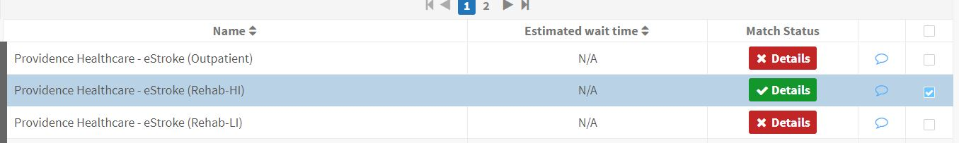
Once the check box is selected, scroll down to the bottom of the list and click on the Add Selected Choices button.
This will move the desired providers into the middle of the screen under the Rated Service Providers section. This is the list of providers that the referral will be send to in the next tab.
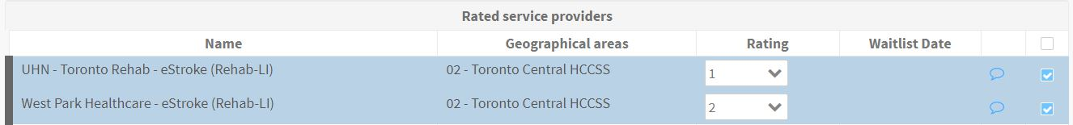
Users can send a referral to a site that does not match, but will have to enter a reason for overriding that match. This should only be done if the user has discussed the patient with the receiving Service Provider and they agree they could accept and provide service for the patient.
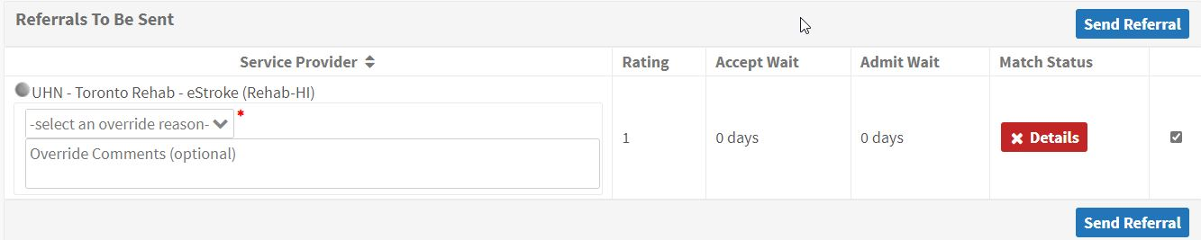
In order to send the referral, the user will need to provide a reason for the Override. Once they do so, they will be able to send the referral to the site.
Send and Manage referrals
Once all of the necessary information has been completed, the user can then move to the Send and Manage Referrals tab. The system will automatically check all of the units that the patient matches to and the user can click on the Send Referral button at the bottom of the screen.
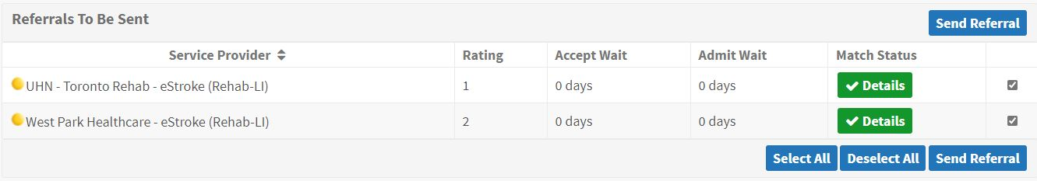
Clicking on the Send Referral button will send the referrals and they will now appear in a Pending status.
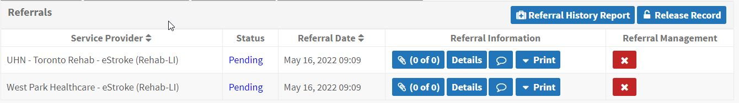

Once the Override reason has been captured, the user can click on the Send Referral button. At this point, all referrals will be sent to the selected EStroke Care Units and appear in a Pending Status. As the receiver actions the referral, the status will change on this page. The 4 statuses that you will see are Pending, Request for Information, Accept and Deny.
For more information on how to respond to each of these statuses, please refer to our Quick Guides: How do I respond to a denied referral and How do I respond to a request for information.
Canceling and Deactivating Referrals
In the event that you need to cancel a referral (patient changes their choice of rehab facility) or need to deactivate a referral (patient does not go to a rehab setting), this can be done in two separate locations.
Cancel a Referral
To cancel a referral to a Service Provider, navigate to the Send and Manage tab in the patient record. On this page, you will click on the red X next to the service provider.
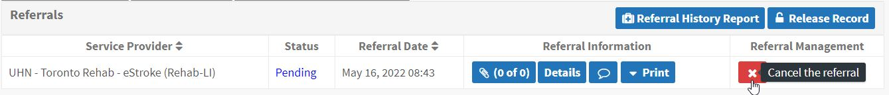
Once you click on the X, a pop-up will appear. Here, you will select the reason you are canceling the referral and add any additional comments.
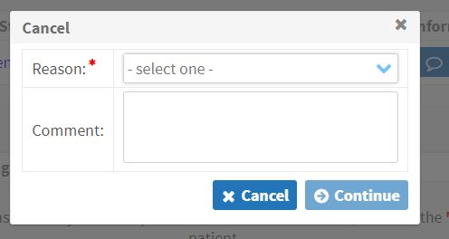
Once you click on Continue, the service provider will no longer be active on the Send and Manage tab and there will be no options under the Referral Management column.

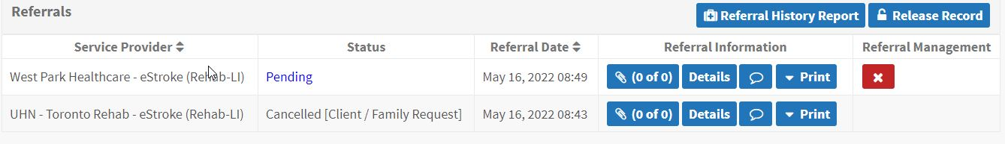
Deactivating a Referral
If a patient is being discharged without going to a rehab setting, you will need to deactivate the referral. To do this, navigate to the Client Details tab. On this page, you will see a button on the right hand side labeled Deactivate.
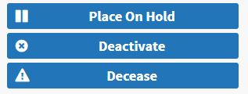
Clicking this button will bring up a new pop up window giving you details on the actions that will happen when you confirm the deactivation. When doing this, include the Estimated Discharge Date for the patient from your facility, or if they have already been discharged, include that date.
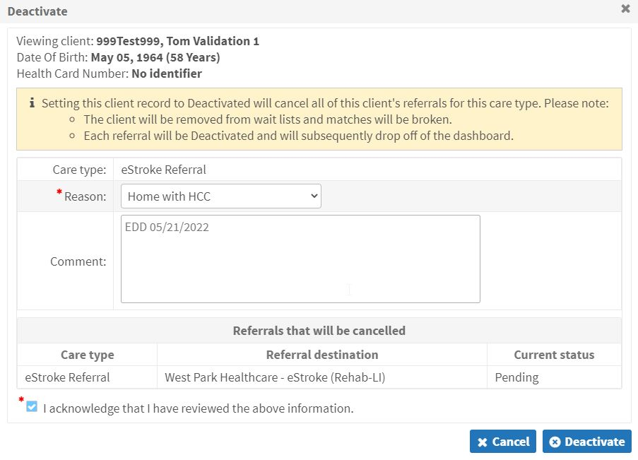
*Note: It is the responsibility of the sending organization to ensure that all referrals on their dashboard are active and awaiting a rehab facility. If the patient is no longer waiting, the sender needs to cancel or deactivate the referrals to remove the patient from the Receiving waitlist.
If the referral has successfully been deactivated, the following message will appear at the top of the screen and the Client Details and Send and Manage Referrals tabs will both be red.
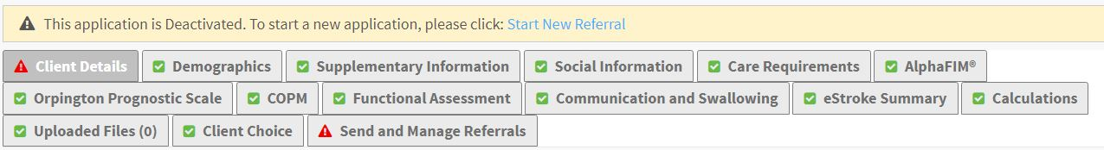
Receiving Referrals
Receiving organizations will Accept new referrals using Service Provider Module. To access this feature, users will click on the Service Provider icon on the Home page of RM&R.
They will then see a list of Service Providers that they can choose to act on behalf of. Users will only see service providers that their accounts have been configured for.
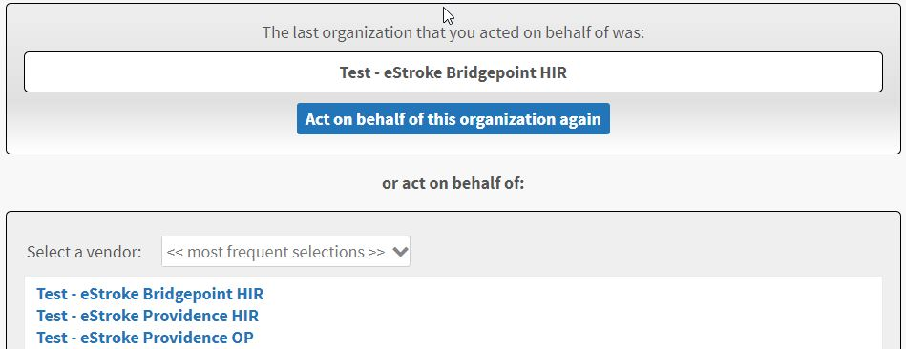
Viewing Referrals
When a user logs in, they will land on the Vacancies list. To view referrals that have been sent, they will need to click on the word Vacancies and select Referrals from the dropdown list.
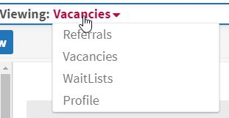
Once they select Referrals, they will be taken to the Referral Dashboard. Here they will see all active referrals for their site.
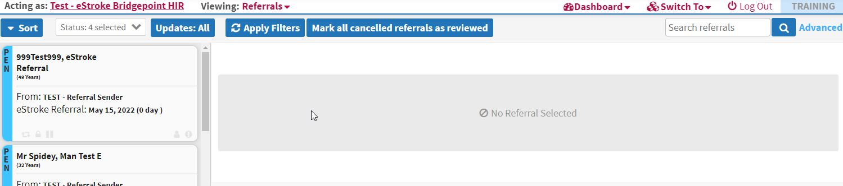
All received referrals appear in a Pending status indicated by the Blue bar on the right side with PEN.
For more information regarding Referral Tiles, please review the associated Quick Guide: What is a referral tile?.

To view the specific patient information, click on the associated tile.
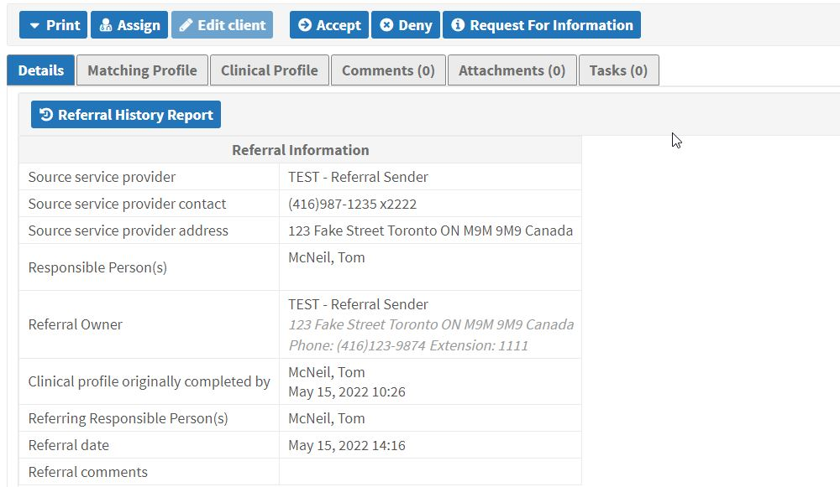
Once in the referral, the user will see the available actions across the top of the referral, in blue.
Accept – Accept the patient to the waitlist, indicating you are able to provide service.
Deny – Deny the patient due to inability to provide service.
Request for Information – Request additional details from the sending organization regarding the patient.
The tabs along the top of the referral allow users to view different details regarding the patient.
Details – Patient Demographics
Matching Profile – The established Matching Criteria for the service provider displaying the criteria the patient matches to (or does not match to)
Clinical Profile – All of the tabs completed in the referral indicating patient function, care requires etc.
Comments – any comments sent from the sender and the receiver regarding the patient
Attachments – any additional documents that are attached by the sending organization
Tasks – currently not used
To review the clinical information for the patient, click on the Clinical Profile tab. This will bring the user to the details for the patient. To make it easier for receiving organizations to review a referral, there is the Summary Tab on the sending side. To view this in the Clinical Profile, click on the Jump to: drop down and select eStroke Summary.
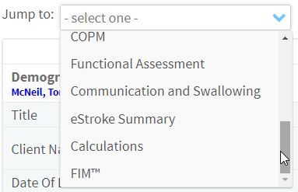
This will display all of the information that the sender entered for the high priority details of the patient.
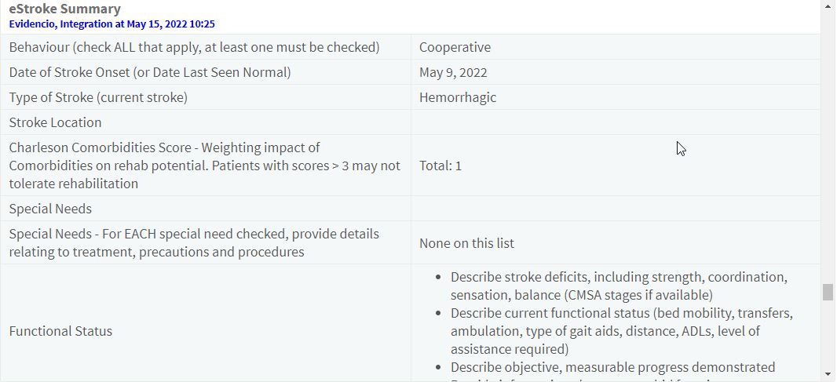

Depending on the information provided, users can act on the referral by selecting one of the Actions previously described.
When Accepting a referral, please enter the estimated admission date in the comment box.
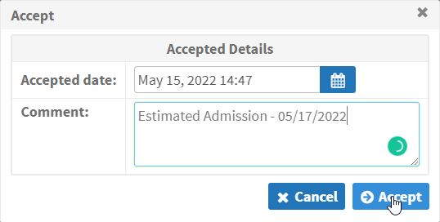
This information goes back to the organization that sent the referral and appears in the Comments tab.
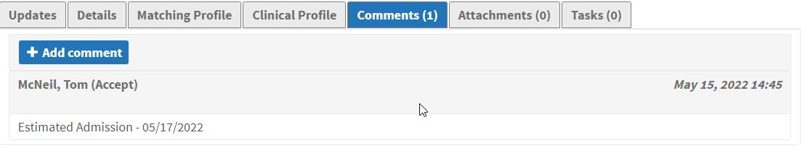

Creating a Vacancy
To create a Vacancy and admit a patient, click on the word Referrals and select Vacancies (reverse of what was done to get to Referrals).
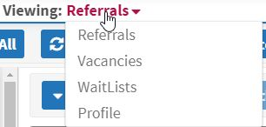

This brings the user to the Vacancies dashboard. Here you will see all available Vacancies for your site.
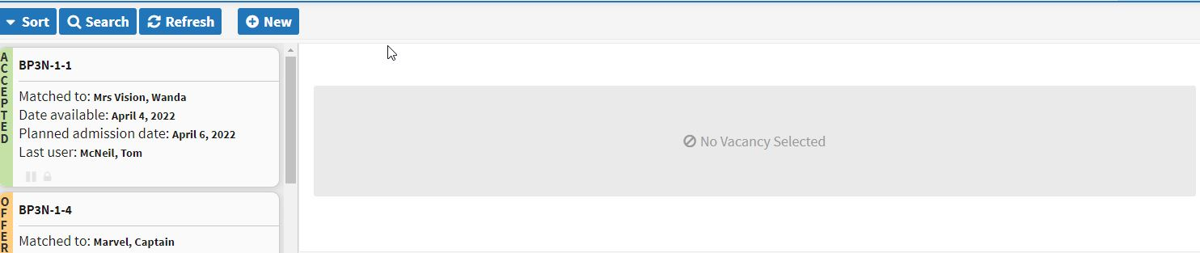
From here, you will be able to see the current status of any existing vacancy and the option to create a new vacancy.
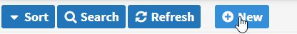
Clicking on the New button will bring up the Search Clients pop-up. To create a vacancy, you must first discharge a patient.
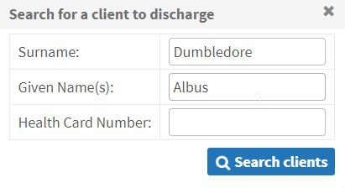
This will bring up the name of admitted patients that match as show below.
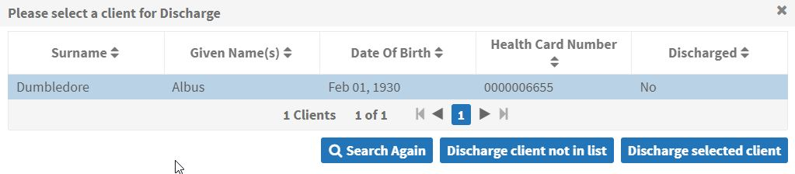
Select the patient name turning the row blue and then click on Discharge selected client. This will bring up the following:
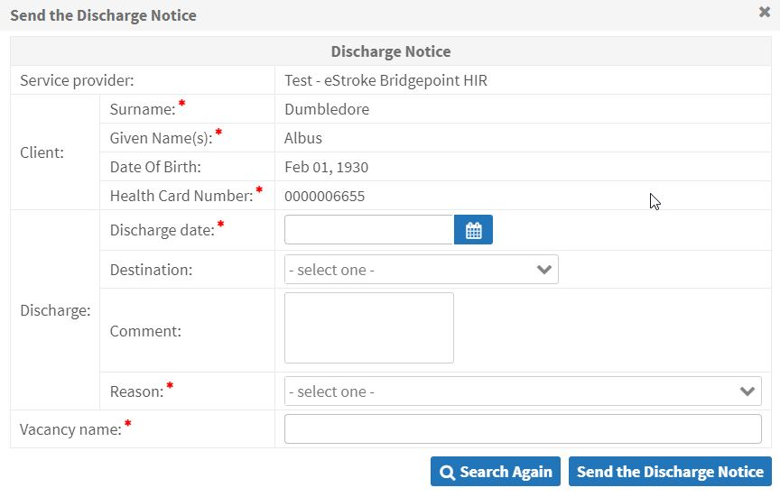
Complete all of fields listed below:
- Discharge date
- Reason for discharge
- Destination
- Vacancy Name

When naming the vacancy, the standard naming format is based on your organization:
Organization | Format (Rehab Level of HIR, LIR or OP)
Hennick Bridgepoint Health | HBH-(Rehab Level)-A
Providence Healthcare | PH-(Rehab Level)-A
St. John’s Rehab | SJR-(Rehab Level)-A
Toronto Rehab | TR-(Rehab Level)-A
West Park | WP-(Rehab Level)-A
Once all of the information is completed, the user can click on Send the Discharge Notice.
This will create the new Vacancy that will in an Internal status meaning nobody outside of your organization will be able to see the Vacancy.
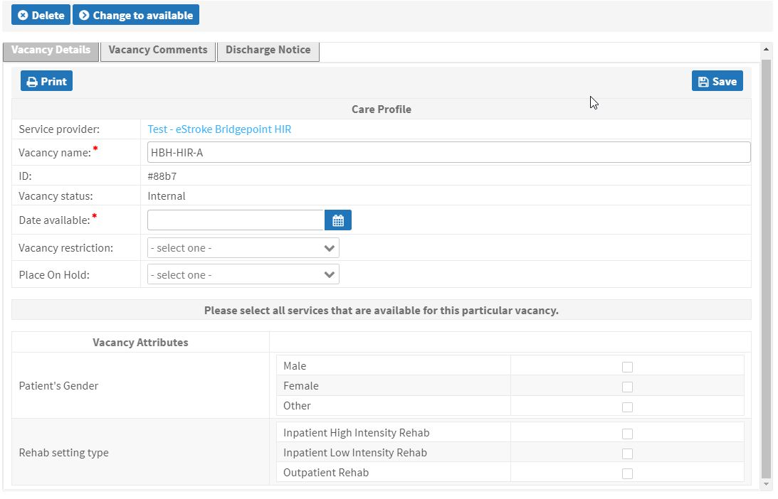
On this page, you will also be able to enter the Date Available. This is the date that you would be able to accept a new patient to the bed. You will also be able to add Vacancy Attributes. These are limited to the Patient’s Gender and the Rehab Setting Type.
This is also where you would put any Vacancy Restrictions that would match the Patient Eligibilities entered by the sending organization. Select one of the three options and click on Save.
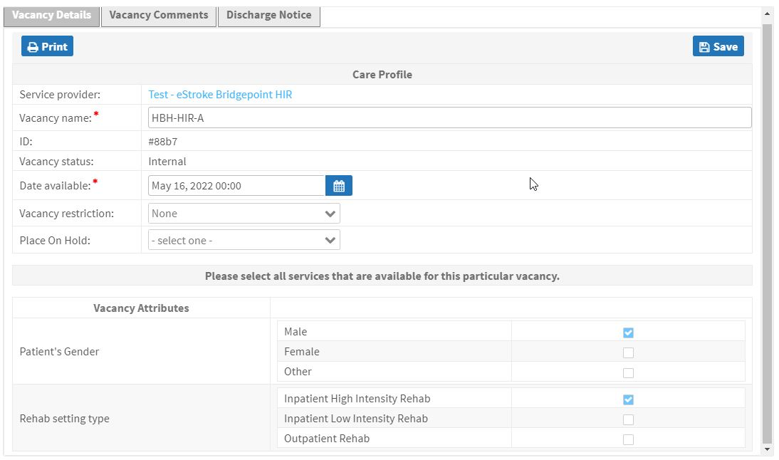
Once you are ready to match the bed to a patient, click on the Change to Available button at the top of the vacancy.
If you have patients that match, you will automatically be taken to the Matches tab and the patient Location and Age will show.
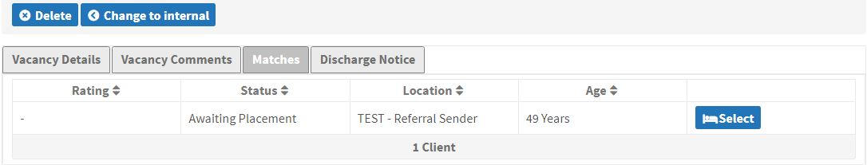
Select the appropriate patient to proceed and review their referral information. Here you will now be able to see the patient details and clinical profile. If you wish to proceed with the patient selected, click on the Proceed to Bed Offer button.
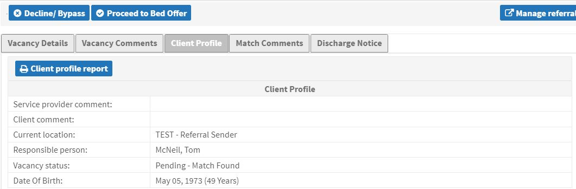
If this is not the correct patient, you can select the Decline/Bypass button. The following pop-up will appear where you can select the appropriate Reason, add a comment and click Decline/Bypass. This does not remove the patient from your Waitlist, it just skips them for this available bed.
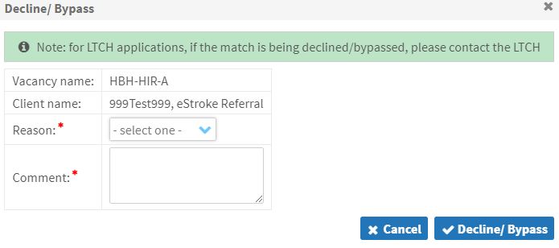
This will take you back to the Matches screen where you can select the next available patient.
Proceeding with the Bed Offer, contact the sending organization and confirm if the patient wants to go to your facility and what the Planned Admission Date would be. This can be entered into the appropriate field and click on the Save button.
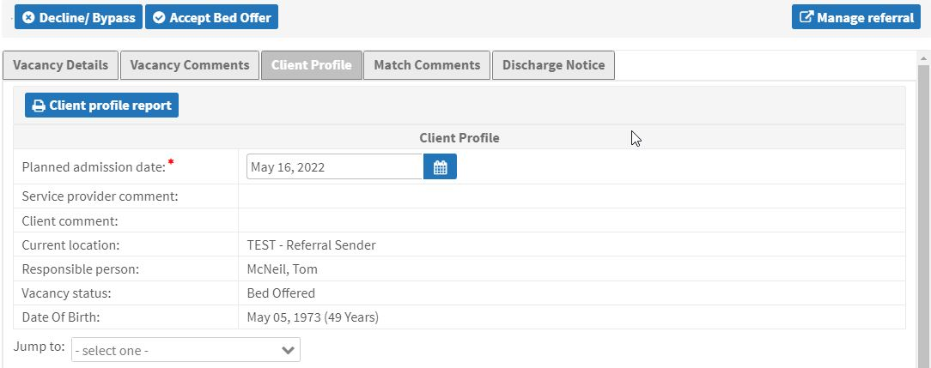
You can now click on the Accept Bed Offer button which confirms that the patient wants to go to your facility. Once the patient arrives at your site, you can proceed to click on the Admit/Provide Service button.
*Note: At any time during this process, up to clicking the Admit/Provide Service button, if the patient changes their mind, you can select the Decline/Bypass and move to the next available patient.

When you click on the Admit/Provide Service a new pop-up will appear for you to confirm the Admission Date and add any comments related to the admission.
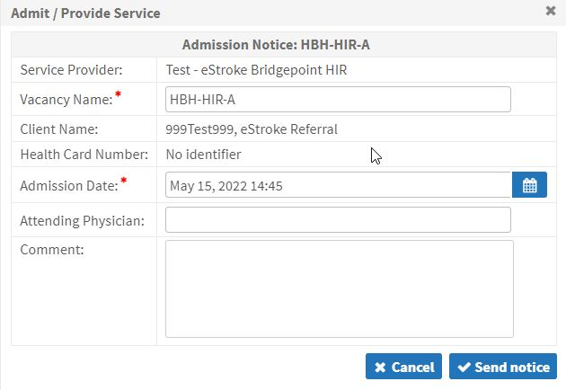
At this point, the patient has now been admitted and the referral closed.
eStroke Vacancy Dashboard
Overview
To aid sending organizations with knowing which organizations currently have beds available, there is a eStroke Vacancy Dashboard that users can review.
Accessing the Dashboard
To access the Vacancy Dashboard for eStroke, users can click on the Dashboard icon along the top navigation pane and select from the drop down.
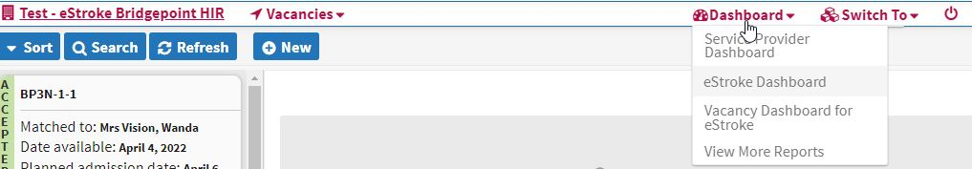
The dashboard provides users with the name of the bed, the Date Available, Number of Patients on the Waitlist and Number of Accepted Referrals.

